**TASK - 1**

**Rotated Triangle coordinates:**

**[[ 0.0000000e+00 0.0000000e+00 1.0000000e+00]**

**[ 1.2246468e-16 -2.0000000e+00 1.0000000e+00]**

**[ 2.0000000e+00 -1.0000000e+00 1.0000000e+00]]**

**Reflected Triangle coordinates:**

**[[ 0 0 1]**

**[ 2 0 1]**

**[ 1 -2 1]]**

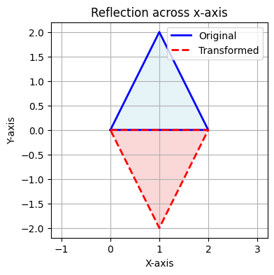

**Sheared Triangle coordinates:**

**[[0. 0. 1. ]**

**[2. 1. 1. ]**

**[1. 2.5 1. ]]**

**array([[0. , 0. , 1. ],**

**[2. , 1. , 1. ],**

**[1. , 2.5, 1. ]])**

**TASK – 2**

